[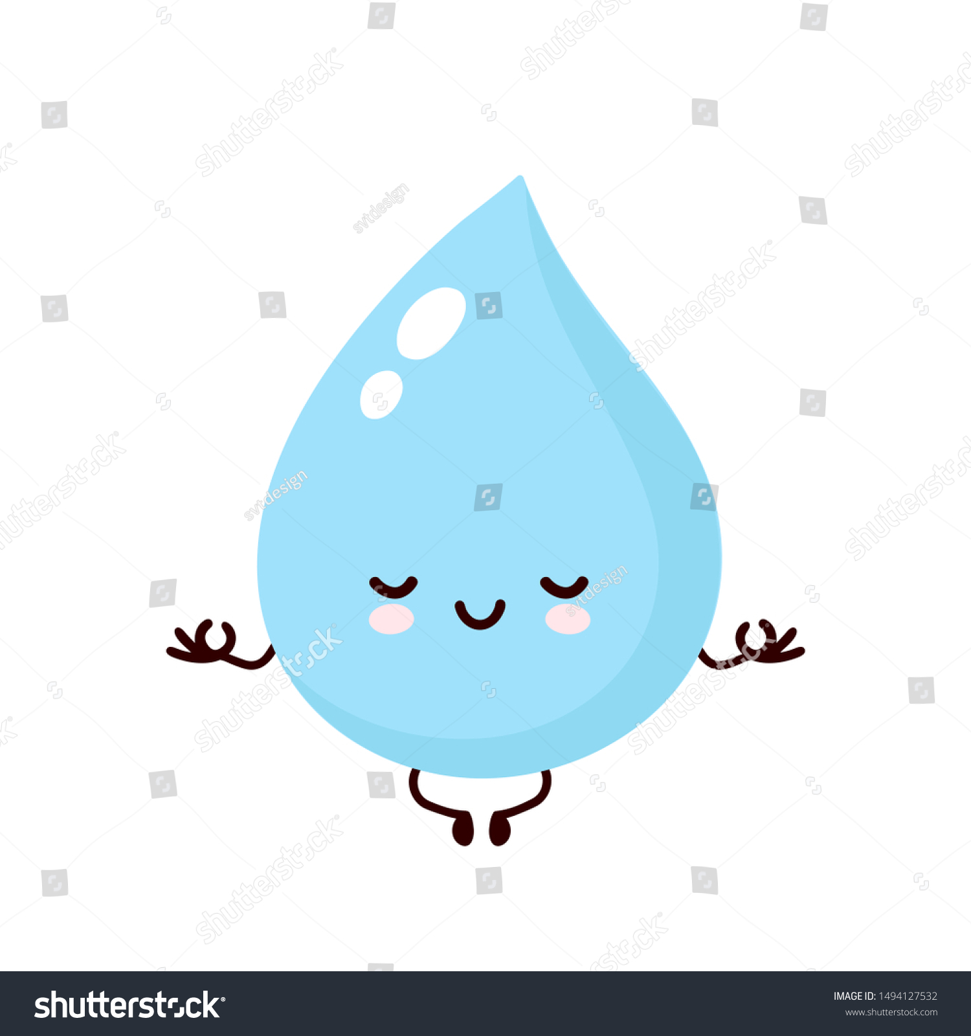](https://www.google.co.uk/url?sa=i&url=https://www.shutterstock.com/image-vector/cute-smiling-happy-water-drop-meditate-1494127532&psig=AOvVaw2A1ull-s1sQqV_ry652SEb&ust=1602365568846000&source=images&cd=vfe&ved=0CAIQjRxqFwoTCMjj0Yu7qOwCFQAAAAAdAAAAABAP)